Home Fine Motor Activities to Do Using at Home Items
- Play-Doh
  - Roll playdoh between both hands into a snake
  - Roll playdoh into a ball
  - Roll playdoh out on a table with both hands or one hand
  - Pinch the top of the playdoh into a “dinosaur” or “dragon”
  - Cut playdoh with scissors
How to make this into a family activity: Instead of play-doh, use cookie dough, bread dough, or pie crusts to teach life skills and still address fine motor skills.
- Q-tips
  - Use q-tips and paint to make “dot paintings”
- Shaving Cream writing
  - Can be done in the tub on the floor to reduce mess, have the child practice writing their name, sight words, letters, and more!
  - Can use a cookie sheet to reduce mess
- Legos
  - Have the child stack the blocks into a tower to address pincer grasp and regulation of force.
  - The child can also write their name, letters, sight words and more on the ground.
- Puzzles
  - Addresses in hand manipulation skills as well as visual perception
- Make your own color by number!
  - Use a quarter and write numbers inside that are associated with a color
  - Have the child color in the numbers based on the “key”
- Coloring Books
  - Use broken crayons (half) to help build muscles in the hands
- Make a “finger twister” board
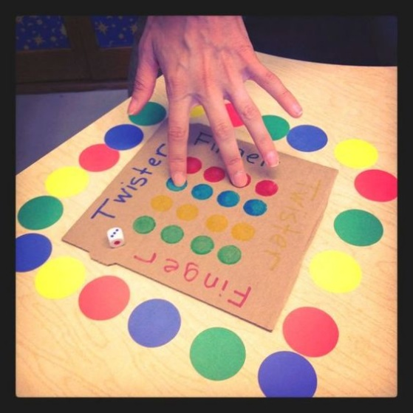
  - Use recycled carboard, markers, and dice to create your own game!
  - Addresses finger isolation and arch development

- Cotton ball transfer
  - Lay the child on their stomach while supporting on their forearms.
  - Put cotton balls on one side of them and have them transfer cotton balls into a container on the other side.
    - Addresses: midline crossing, development of fine pincer grasp, web space, and arches of the hand which are all needed for academic written work.
- Clothes pin and a hanger
  - Gather clothespins and label them with numbers or letters
  - Have the child match numbers or colors or count
  - The child will squeeze open the clothespin and hang it on the cooresponding location (whether it be a hanger, wire basket, shirt, etc)
    - Addresses: Development of web space and arches. Uses visual perceptual skills.
